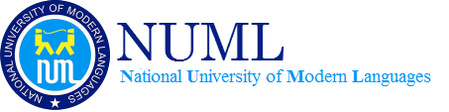

**Name:** Ashna Wasif

**Roll Number:** 2791

**Class:** BSCS 7B (Morning)

**Subject:** Information Security

**Assignment No.:** 1

**Submitted To:** Dr Zia Ur Rehman

**Date:** 3rd March, 2025

**Question:**

Implement crack of Caesar cipher using python.

* Program should take cipher text.
* It should display all possible plain texts.

**Solution:**

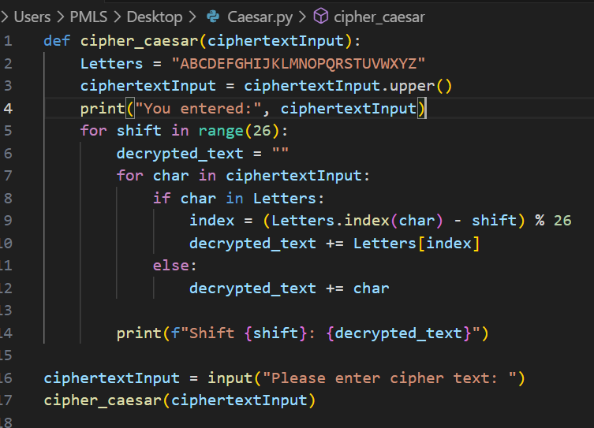Python Program:

Output:

